**REG NO:**

**SRM Institute of Science and Technology**

**College of Engineering and Technology**

**School of Computing**

SRM Nagar, Kattankulathur – 603203, Chengalpattu District, Tamilnadu

**Academic Year: 2023-24 (ODD) Descriptive Question Paper**

**Test: CLA-T3** **Date: 09-11-2023**

**Course Code & Title: 18CSE308T -AWS Solution Architect** **Duration:** **80 Minutes**

**Year & Sem: III Year / V Sem** **Max. Marks:** **40**

**Course Articulation Matrix: *(to be placed)***

|  |  |  |  |  |  |  |  |  |  |  |  |  |  |
| --- | --- | --- | --- | --- | --- | --- | --- | --- | --- | --- | --- | --- | --- |
| **S.No.** | **Course Outcome** | **PO1** | **PO2** | **PO3** | **PO4** | **PO5** | **PO6** | **PO7** | **PO8** | **PO9** | **PO10** | **PO11** | **PO12** |
| 1 | **CO1** | 2 |  |  |  | 3 |  |  |  |  |  |  |  |
| 2 | **CO2** | 3 |  |  |  |  |  |  |  |  |  |  |  |
| 3 | **CO3** | 2 |  |  | 3 |  |  |  |  |  |  |  |  |
| 4 | **CO4** |  | 3 |  |  |  |  |  |  |  |  |  |  |
| 5 | **CO5** |  |  |  | 3 |  |  |  |  |  |  |  |  |

|  |  |  |  |  |  |  |
| --- | --- | --- | --- | --- | --- | --- |
| **Part - B**  **(5 x 4 M = 20 Marks)**  **Instructions: Answer any 5. NOTE: 3 Questions from Unit 4 & 2 Questions from Unit 5 has to be answered.** | | | | | | |
| **Q. No** | **Question** | **Marks** | **BL** | **CO** | **PO** | **PI Code** |
| **11** | Describe a real-world scenario where microservices architecture would be more suitable than a monolithic architecture. Explain how microservices would be implemented to address the specific needs of that scenario. | **4** | **L2** | **4** | **1** | **1.6.1** |
| **12** | Describe a specific use case where AWS Lambda is an ideal choice for implementing a microservice. Include details about how Lambda functions can be triggered and integrated within a microservices architecture. | **4** | **L2** | **4** | **2** | **2.6.4** |
| **13** | Describe a scenario where you would recommend using Amazon Redshift for data analysis and reporting. Outline the steps involved in setting up a Redshift cluster and loading data into it. | **4** | **L2** | **4** | **1** | **1.6.1** |
| **14** | Describe a practical use case for AWS Glue in a data processing pipeline. Outline the steps involved in creating and running an ETL job using AWS Glue. | **4** | **L2** | **4** | **1** | **1.7.1** |
| **15** | Explain the difference between CloudWatch Logs and CloudWatch Metrics in AWS CloudWatch. | **4** | **L2** | **4** | **2** | **2.6.4** |
| **16** | Explain the two tiers of AWS Shield and the differences between AWS Shield Standard and AWS Shield Advanced. | **4** | **L2** | **5** | **1** | **1.6.1** |
| **17** | Describe a real-world scenario where AWS WAF would be essential for securing a web application. Outline the steps to configure and deploy AWS WAF rules to address specific security threats. | **4** | **L2** | **5** | **1** | **1.7.1** |
| **18** | Explain the primary components of an Amazon VPC, such as subnets, route tables, security groups, and Network Access Control Lists (NACLs). | **4** | **L2** | **5** | **2** | **2.6.4** |
| **Part - C**  **(2 x 10 M = 20 Marks)** | | | | | | |
| **19** | 1. Analyze the significant considerations and distinctions that you, as a security consultant, would highlight when addressing a financial institution's concerns about DDoS attacks on critical applications. Evaluate the effectiveness of AWS Shield in mitigating various types of DDoS attacks and discuss the specific attributes that differentiate AWS Shield Standard from AWS Shield Advanced in safeguarding against evolving threats   [ or ]   1. Examine the complex thought process you would apply as a security analyst entrusted with safeguarding a complex AWS infrastructure. Provide an in-depth assessment of the strategies involved in effectively utilizing AWS CloudTrail logs to perform security analysis and troubleshooting, highlighting the key processes for detecting unauthorized access and abnormal activities within the environment | **10** | **L3** | **4** | **1** | **1.7.1** |
| **20** | 1. Examine the intricate thought process you would apply as the lead data architect entrusted with designing a data pipeline for a large-scale e-commerce platform. Provide an in-depth assessment of the strategies employed for utilizing AWS Glue to handle data ingestion, cleansing, and transformation, emphasizing its significance in supporting advanced analytics and comprehensive reporting.   [ or ]   1. Analyze the pivotal considerations and distinctions you would take into account as a systems architect responsible for enhancing microservices deployment strategies. Evaluate your approach to comparing and contrasting serverless computing (AWS Lambda) and container orchestration solutions (Amazon ECS or Kubernetes), highlighting the unique advantages and limitations of each approach in the context of microservices deployment | **10** | **L3** | **5** | **2** | **2.6.4** |

**\*Program Indicators are available separately for Computer Science and Engineering in AICTE examination reforms policy.**

**Course Outcome (CO) and Bloom’s level (BL) Coverage in Questions**

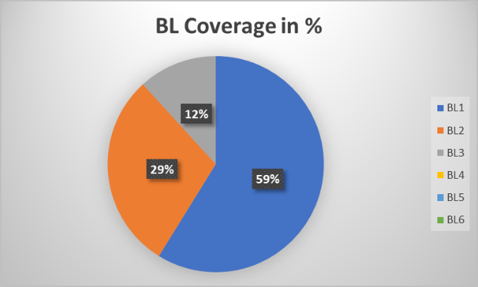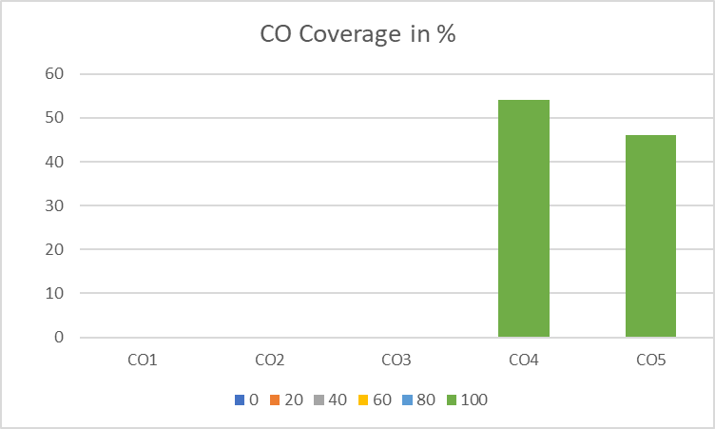

**Approved by the Audit Professor/Course Coordinator**